FURNITURE SURPLUS SALE

WHERE: DONALD W. REYNOLDS RAZORBACK STADIUM

WHEN: SATURDAY, DECEMBER 16, 2017
1:00 PM – 5:00 PM

ENTRANCE: GATE 16 OFF STADIUM DR.

ALL SALES ARE FINAL. SALES TAX INCLUDED.
ITEMS MUST BE REMOVED IMMEDIATELY AFTER PURCHASE WHILE SUPPLIES LAST

CHAIRS
ALL SALES ARE FINAL. ITEMS MUST BE REMOVED IMMEDIATELY AFTER PURCHASE. SALES TAX INCLUDED.
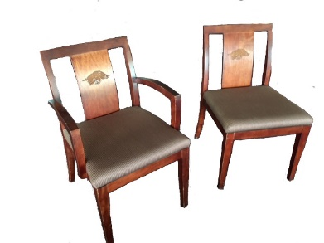
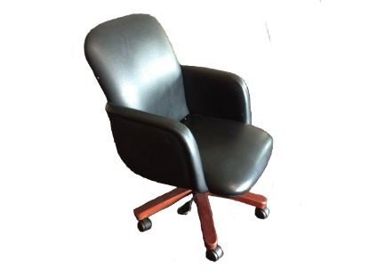

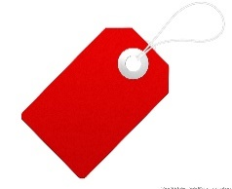
$20
$25/EA

BLACK/GREY ROLLING CHAIR WOODEN CHAIR WITH HOG LOGO (WITH & WITHOUT ARMS)
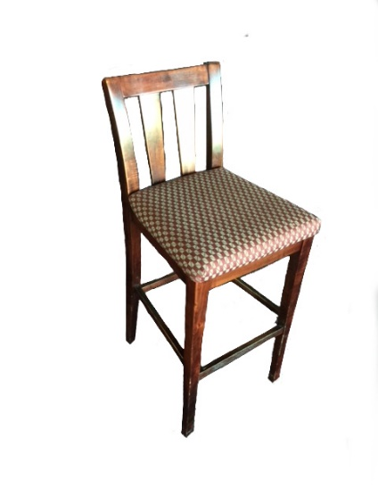
35”H X 24”W X 24”D WITH ARMS: 35”H X 22”W WITHOUT ARMS 35”H X 20”W
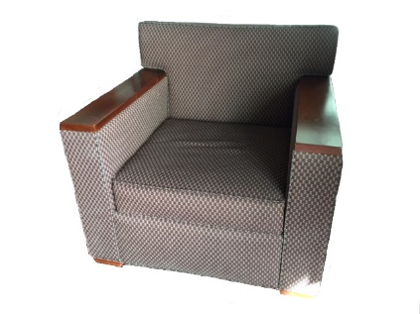
$15
PATTERNED WITH WOODEN ARMS
33”H X 30”W X 30”D
HI-TOP CHAIR
$25
42”H X 17”W X 18”D

TABLES
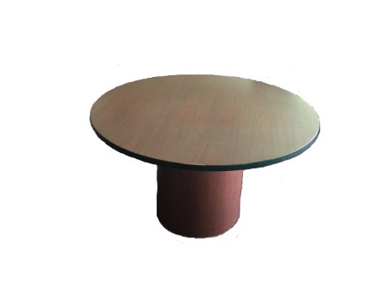
ALL SALES ARE FINAL. ITEMS MUST BE REMOVED IMMEDIATELY AFTER PURCHASE. SALES TAX INCLUDED.
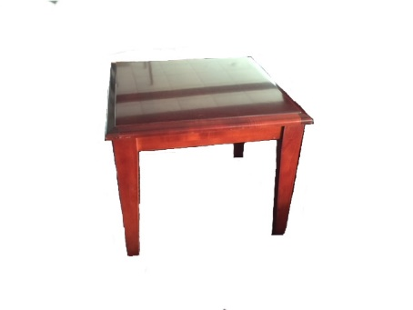
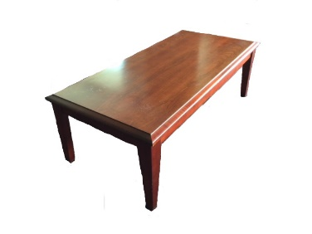
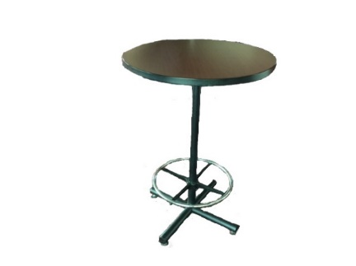
$15
$25
$30
$20

ROUND TABLE COFFEE TABLE END TABLE COCKTAIL TABLE
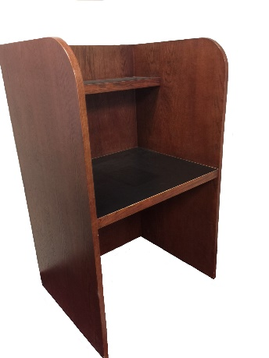
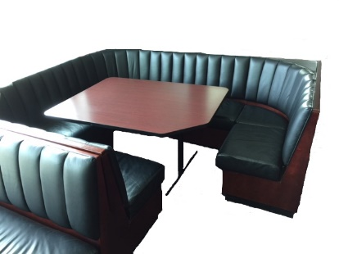
29”H X 48” DIA. 16”H X 50”W X 24”D 20”H X 24”W X 24”D 42”H X 30” DIA.
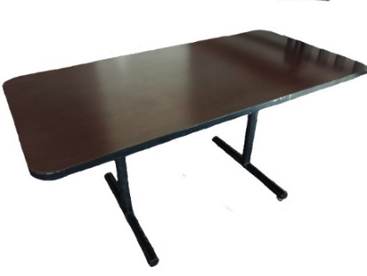
$5
$25

$50
LARGE BOOTH WITH TABLE LG & SM CUBICLE (LG IN PHOTO) RECTANGULAR TABLE
3’H X 8’W X 7’D 60” H X 36”W X 30”D 29”H X 60”W X 30”D

