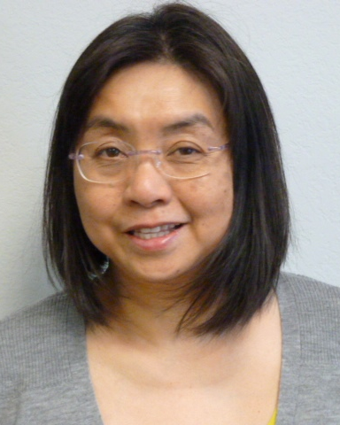
Kaoru U. Porter received the B.S. and M.S. degrees in electrical engineering from the University of Arkansas at Fayetteville, in 1995 and 1997, respectively. Currently holding the title of Research Associate, Ms. Porter manages the operation of the High Density Electronics Center (HiDEC) Ceramic Integration Laboratory housed within the University of Arkansas’ Department of Electrical Engineering. Ms. Porter has been in her current position since 2007 providing equipment and process training associated with low temperature co-fired ceramic (LTCC).

